Receiving
The Receiving page will only display the requisitions that you have the ability to receive based on your user profile. Receiving is performed by requisition number within the purchase order number. The page shows purchase orders in the summary portion of the page and associated requisitions in the detail portion of the page.
Purchase orders created in the current accounting period can be received in the next accounting period.

_____1. Set up Receiving. From District Administration > Options > Purchasing select the Create Receiving Payables. A payable transaction will automatically be created on the Check Processing - PO page in Finance.
Select the options that you will use for Receiving:
- If Use Blind Receiving is selected, order quantities are not shown on this page.
- If Allow Partial Receiving is not selected, only complete requisition items can be received.
- If Allow Receiving Overage is not selected, only the original item quantity ordered or less can be received less can be received.

_____2. Retrieve desired requisition. From Maintenance > Receiving.
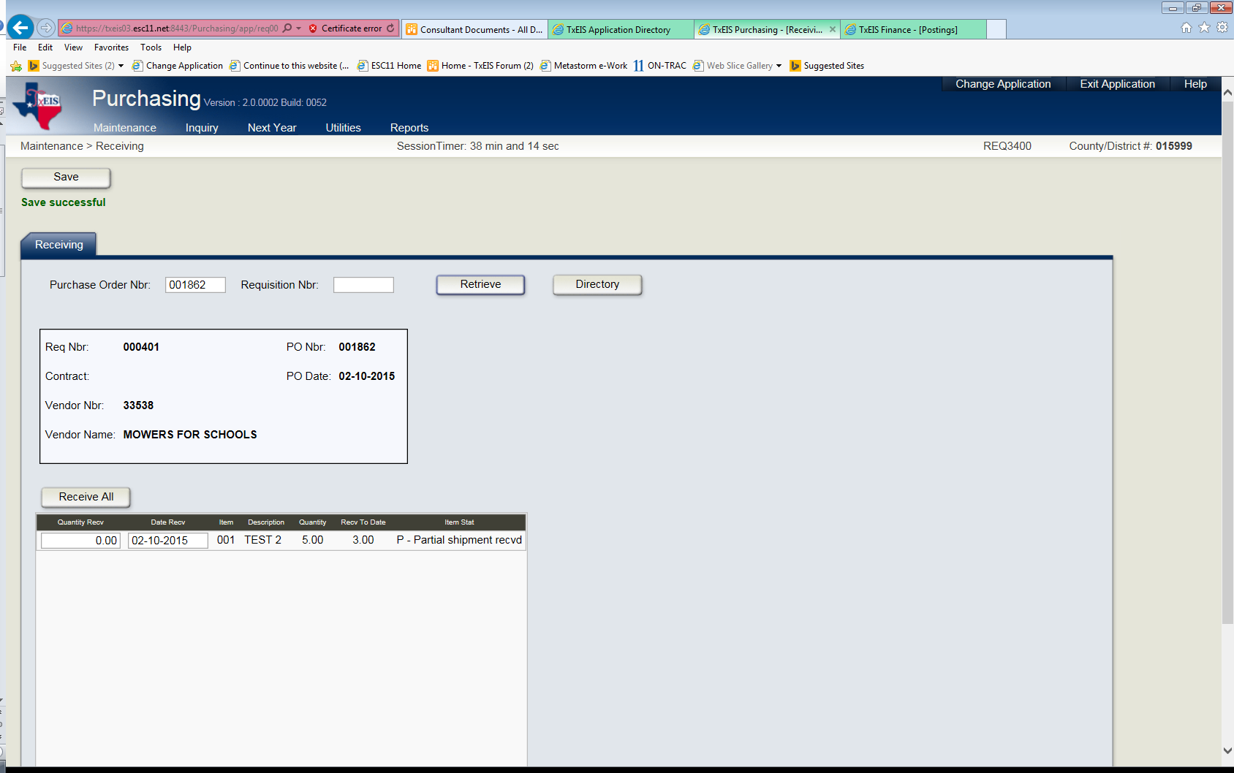
- To receive a purchase order, enter the purchase order number in the Purchase Order Nbr field, or enter the requisition number in the Requisition Nbr field, and then click Retrieve.
- Click Directory to search for a purchase order by purchase order number, vendor number, requisition number, or vendor name.

_____3. Reviewing the requisition. Requisition details for the selected purchase order are displayed in the table at the bottom of the page.
Note: Purchasing options previously selected on the District Administration > Options > Purchasing Options page affect the information displayed and determine if certain requisition items can be received on this page.

_____4. Select the requisition line item to receive.
Note: If a requisition contains line items generated by Finance when a purchase order is changed, payable check transactions can only be received but not created.
In the Quantity Received field, type the number of items received. If you received a partial order, enter what you actually received and the system will keep a tally for you. When the items are received next, retrieve the PO. Only items not fully received will display and an Item Status of P – Partial shipment received will show. Enter the number of items received in the shipment and save.
The system populates the Date Received field with the system date. The user can edit the date that the items were received.
Click Save, or select another requisition line item to continue receiving items.
To automatically receive all the items in the detail portion of the page, click Receive All, and the system will automatically complete the order.
Click Save to process the purchase orders selected.
If all items are received, the PO will no longer be available on this screen after closing.
Once the full order has been received, the Item Status will read F – Complete Shipment Received. A purchase order is not displayed if the balance is zero and all check transactions have been completed (printed or changed to district).

_____5. Verify information in Finance. Once you enter Quantity Received it will show on the Finance > Maintenance > Posting > Check Processing PO tab.

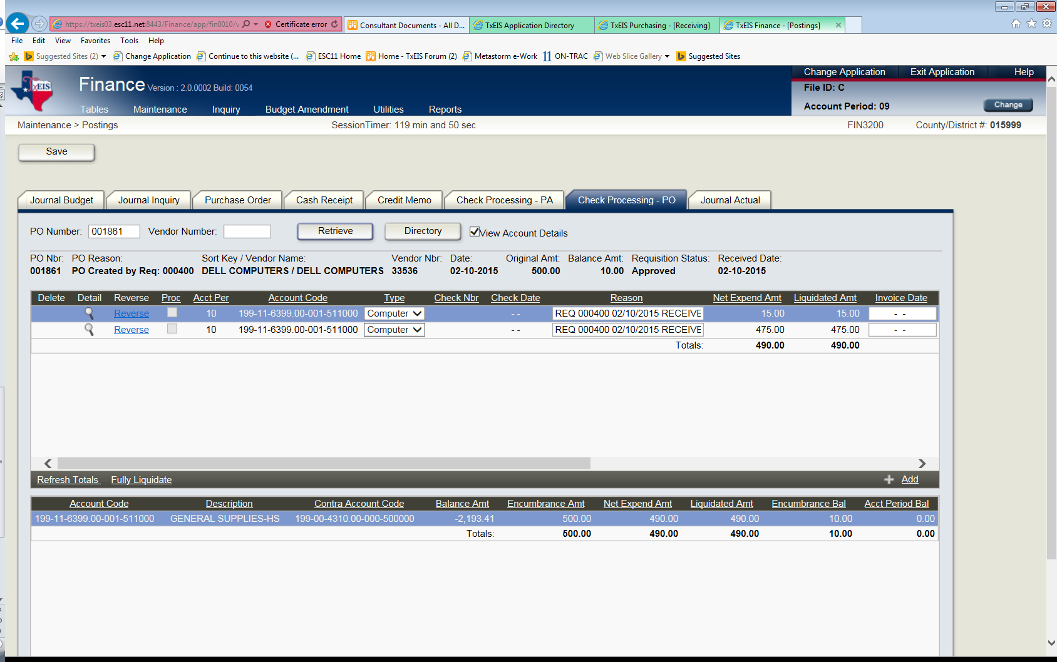

_____6. Partial PO received and District will not receive the remaining items.
BEFORE you liquidate any remaining balance, you must 1st print the check for the items received.
Example: If you only received 2 of the 3 items. Enter the amount you received in Purchasing > Maintenance > Receiving.
Go to Finance > Maint. > Check Processing PO. The amount to pay should already show once you have entered the total received in Receiving.
The vendor and the amount to pay will not show on the Finance > Check Processing until the box is selected to Print and the box is selected for Separate Check on the line item you are paying in Check Processing PO.
Do not delete the next line item with 0 totals. Do not uncheck the Print box on the zero line item either.
Go to Finance > Maintenance > Check Processing. Print the check for items received.
You now have a Balance Amt of $15.00 that you need to remove from the Liquidated Amount.
Go to Finance > Maintenance > Purchase Order and change the $105.00 (that was the original PO amount) in Encumbrance to the amount that is in the Liquidated Bal amount of $90.00.
SAVE

Once this is cleared and saved the Check Processing PO will not be shown.
The Inquiry screen will show the correction.

